LAB 2

* 1. Write a program that takes a student's score as input and outputs the corresponding grade based on the following scale:

A: 90-100

B: 80-89

C: 70-79

D: 60-69

**Program:**

**package** demo;

**import** java.util.Scanner;

**public class** student_score {

**public static void** main(String[] args) {

// **TODO** Auto-generated method stub

Scanner s=**new** Scanner(System.***in***);//creating the Scanner object

**int** n1,n2,n3,total;

**float** avg;

System.***out***.println("Enter score of Subject 1 "); n1=s.nextInt();//taking first score as an input System.***out***.println("Enter score of Subject 2 "); n2=s.nextInt();//taking second score as an input System.***out***.println("Enter score of Subject 3 "); n3=s.nextInt();//taking third score as an input total=n1+n2+n3;// calculating the sum of three scores of student System.***out***.println("Total Score is "+total+" out of 300"); avg=total/3;// calculating the average of three scores of student System.***out***.println("Your Average is: "+avg);

**if**(avg>=90 && avg<=100)//checking whether average is greater and equal to 90 and less than to 100

{

System.***out***.println("You scored A Grade");

}

**else if**(avg>=80 && avg<=89)//checking whether average is greater and equal to 80 less than to 89

{

System.***out***.println("You scored B Grade");

}

**else if**(avg>=70 && avg<=79)//checking whether average is greater and equal to 70 less than to 79

{

System.***out***.println("You scored C Grade");

}

**else if**(avg>=60 && avg<=69)//checking whether average is greater and equal to 60 less than to 69

{

System.***out***.println("You scored B Grade");

}

to 59

**else**//checking whether average is greater and equal to 50 less than

{

System.***out***.println("Sorry!! you are failed in this exam");

}

}

}

# Output:

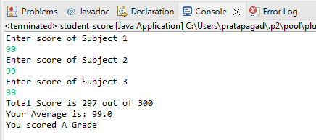

* 1. Write a program to check if a given year is a leap year. (A year is a leap year if it is divisible by 4 but not by 100, or it is divisible by 400.)

# Program:

**package** demo;

**import** java.util.Scanner;

**public class** Leap_year {

**public static void** main(String[] args) {

// **TODO** Auto-generated method stub

Scanner s=**new** Scanner(System.***in***);/Creating the Scanner object

**int** year;//declaring the variables System.***out***.println("Enter the year: "); year=s.nextInt();//taking a year as an input

**if**(year%4==0)//checking whether remainder of entered no. is equal to

0 or not

{

}

**else**

{

}

System.***out***.println(year+" is a leap year");

System.***out***.println(year+" is not a leap year");

}

}

# Output:

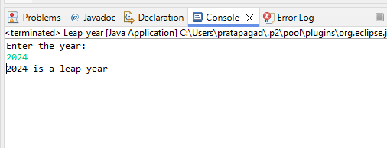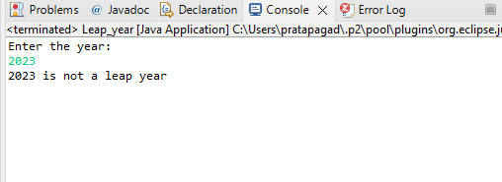

* 1. Write a program that takes an integer as input and checks if it is positive, negative, or zero.

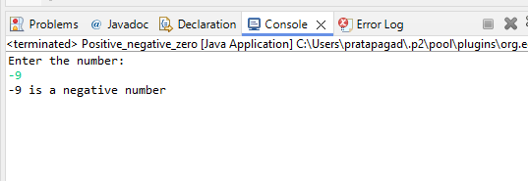

# Program:

**package** demo;

**import** java.util.Scanner;

**public class** Positive_negative_zero {

**public static void** main(String[] args) {

// **TODO** Auto-generated method stub

Scanner s=**new** Scanner(System.***in***);//creating the Scanner object

**int** n;//declaring the variable System.***out***.println("Enter the number: "); n=s.nextInt();//taking the number as an input **if**(n>0)//checking whether the no. is positive

{

System.***out***.println(n+" is a positive number");

}

**else if**(n<0)//checking whether the no. is negative

{

System.***out***.println(n+" is a negative number");

}

**else**//the no. is Zero

{

System.***out***.println("The number is Zero");

}

}

}

# Output:

* 1. Write a program that prints numbers from 1 to 10 using a loop.

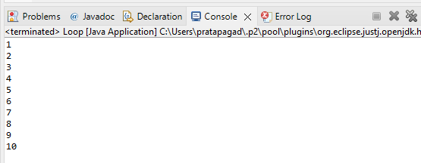

# Program:

**package** demo;

**public class** Loop {

**public static void** main(String[] args) {

// **TODO** Auto-generated method stub

**int** i=1;//decalring the varaible

**while**(i<=10)//for(i=1;i<=10;i++)//It will rotate the loop 10 times for printing the value of i

{

System.***out***.println(i); i++;

}

}

}

# Output:

* 1. Write a program that takes an integer N as input and calculates the sum of entered numbers.

# Program:

**package** demo;

**import** java.util.Scanner;

**public class** Sum_entered_Number {

**public static void** main(String[] args) {

// **TODO** Auto-generated method stub

Scanner s=**new** Scanner(System.***in***);//declaring the Scanner Object **int** n,sum=0,i;//declaring the variables System.***out***.println("Enter the number: "); n=s.nextInt();//taking the no. as an input

**for**(i=1;i<=n;i++)//it will rotate the loop for 10 times to change the value of i

{

sum+=i;//it will calculate the total of value of n

}

System.***out***.print("The Sum of entered number is: "+sum);

}

}

# Output:

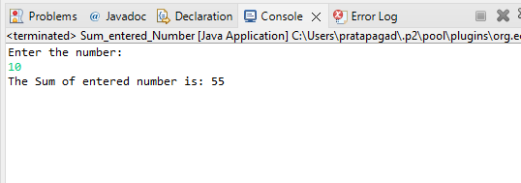

* 1. Write a program that takes an integer as input and prints its multiplication table up to 10.

# Program:

**package** demo;

**import** java.util.Scanner;

**public class** Multiplication_Table {

**public static void** main(String[] args) {

// **TODO** Auto-generated method stub

Scanner s=**new** Scanner(System.***in***);//declaring the Scanner Object **int** n,i=1,ans;//declaring the variables System.***out***.println("Enter the number: "); n=s.nextInt();//taking the no. as an input

**while**(i<=10)//It will rotate the loop for 10 times

{

ans=n*i;//product of n and i

System.***out***.println(n+" X "+i+" = "+ans);//printing the output i++;//updation!!! it will increase the value of i by 1

}

}

}

# Output:

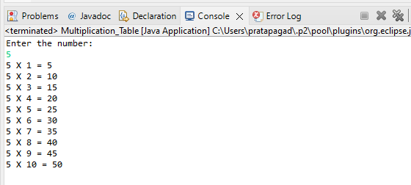

* 1. Write a program that takes a positive integer as input and prints its digits in reverse order.

# Program:

**package** demo;

**import** java.util.Scanner;

**public class** Reverse_Order {

is 0

**public static void** main(String[] args) {

// **TODO** Auto-generated method stub

Scanner s=**new** Scanner(System.***in***);//declaring the Scanner Object **int** n,rev=0,remainder;//declaring the variables System.***out***.println("Enter the number: "); n=s.nextInt();//taking the no. as an input

**int** m=n;//Assigning the value of n in m

**while**(n>0)//It will rotate the loop for 10 times till the value of n

{

remainder=n%10; //calculates the remainder of n rev=rev*10+remainder;//calculates the reverse with the help of

remainder

}

n=n/10;//it helps to pruning/cut down one digit from n

the output

}

}

# Output:

System.***out***.println("The reverse order of "+m+" is "+rev);//printing

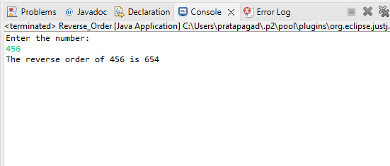

* 1. Create a class Animal with a method makeSound() that prints "Some generic animal sound". Create another class Dog that extends Animal and overrides the makeSound() method to print "Bark". Write a main method to demonstrate calling the makeSound() method on an Animal reference holding a Dog object.

# Program:

**package** demo;

**class** Animal //declaring the Animal class

{

**public void** makeSound() //declaring the makeSound method

{

System.***out***.println("Hmmm");//printing some sound

}

}

**class** Dog **extends** Animal //declaring the dog class which inherit to Animal class

{

@Override

**public void** makeSound() //declaring the makeSound method which overrides to the method of parent class

{

System.***out***.println("Bark");//printing the sound of Dog

}

}

**public class** Main

{

**public static void** main(String[] args)

{

// Creating an Animal reference holding a Dog object Animal animal = **new** Dog();

// Calling the makeSound() method animal.makeSound();

}

}

# Output:

